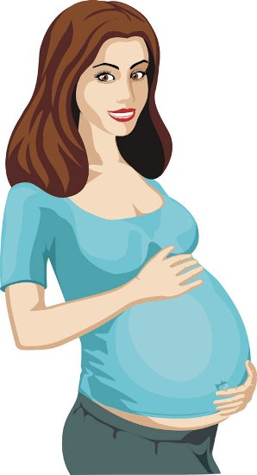What is adoption?

1. A baby is born by one mother

C:\Users\David Frederick\AppData\Local\Microsoft\Windows\Temporary Internet Files\Content.IE5\P1662Y59\MC900436163[1].wmf

1. A different mommy & daddy raise the baby